**Proposed level of Achievement:** Apollo 11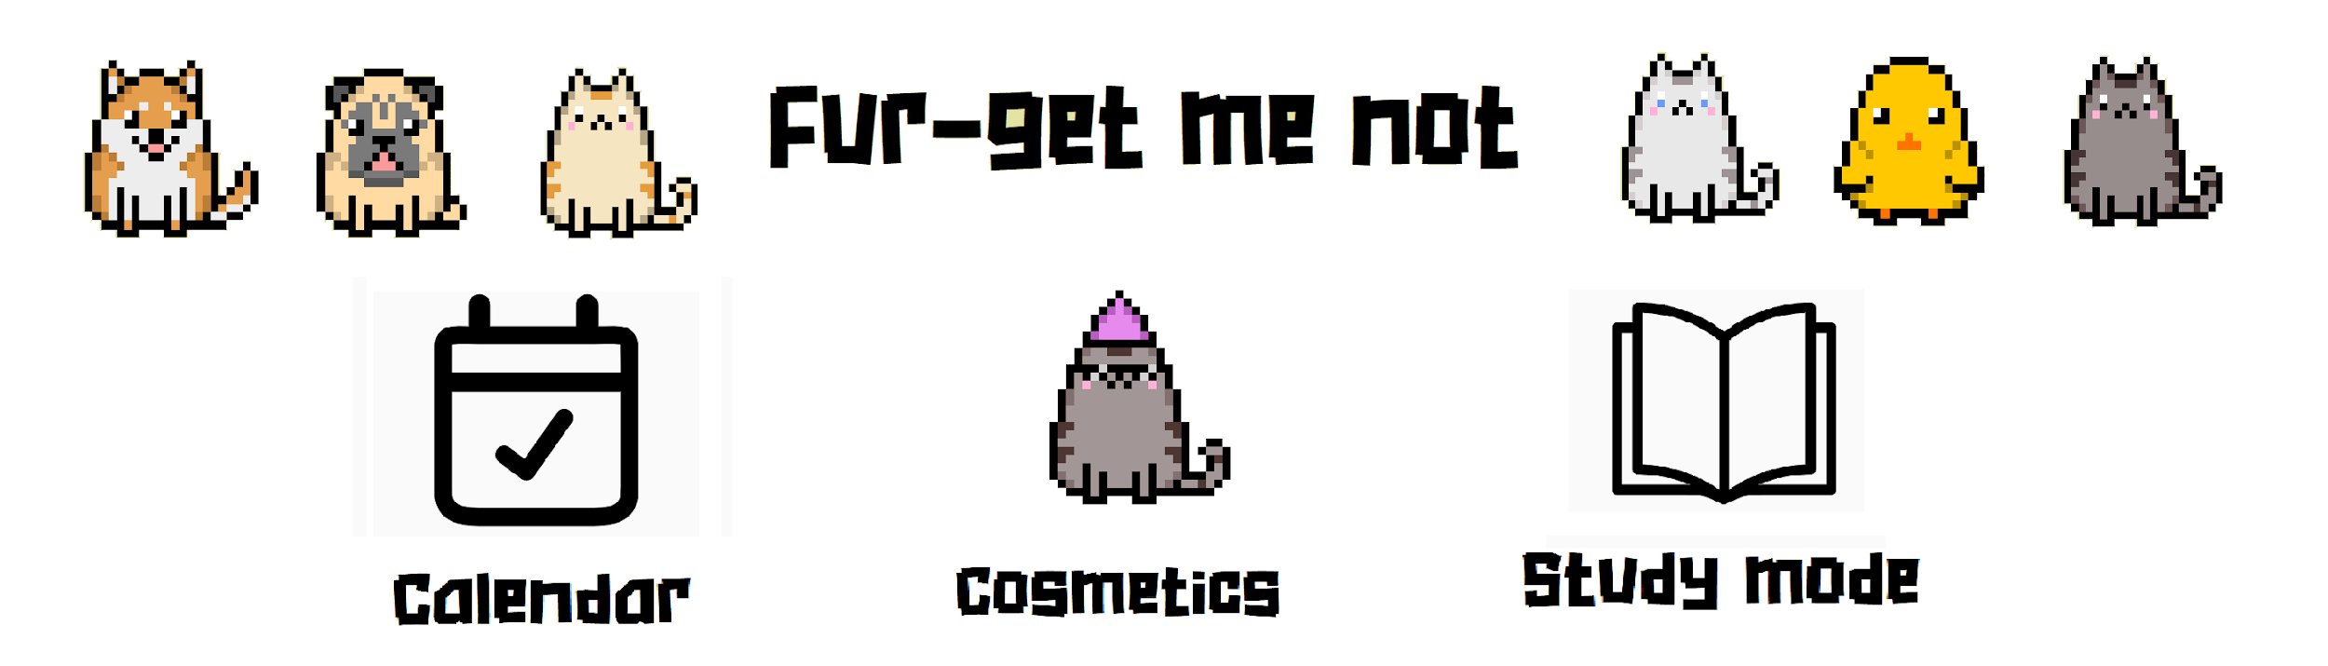

**Motivation**

As busy students with many tasks and activities throughout the semester, it is difficult and boring to keep track of the numerous assignments and deadlines that we have. It is also hard to stay focused and meet these deadlines as we get easily distracted by our phones while studying.

If only there was an all inclusive application that could help us remember important dates and at the same time, help us to focus when we need to, while helping us to relax and enjoy during our breaks.

**Aim**

To have adorable interactive virtual pets that will remind you of your deadlines and help you to stay focused while studying.

**User stories**

As a student, I would be able to collect pets and cosmetic items using coins.

As a student with various deadlines, I would be able to create and add events into a calendar in the application.

As a student who needs to study, I would be able to activate a study mode that whenever I use my phone, my pet will remind me that I should be studying.

**Scope of project**

The mobile application made using Unity will be the basis of our project that contains all the features of our app such as study mode, calendar, store and pet viewing areas.

Features to be completed by the mid of June:

* We aim for the application to be able to store events in the calendar and for study mode to be working.
* Limited pets and cosmetics available

Features to be completed by the mid of July:

* Able to send push notifications as reminders when an event in the calendar happens
* Reward users based on the deadlines they meet and for time spent in study mode
* Possible addition of mini games that users would be able to play with their pets
* Possible friend feature which would allows users to add friends and send reminders

**How are we different from similar platforms**

Calendar

We want our app to be exclusively for deadlines and school related dates. We also have a reward system that rewards users for meeting assignment deadlines. Furthermore our app will make use of our virtual pets in the reminders to add a more playful feel.

Forest Stay Focused

This is an application that helps you to be productive. When you plant a seed, it gradually grows into a tree while you leave the app on, however if you close the app and open other applications, the tree instantly dies.

This app was one of the motivations behind our project and we aim to make our app more interactive and engaging by having pets instead of just simply planting trees. Our application also has more features that all aim to help you improve productivity.

